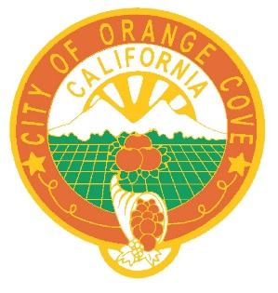

NOTICE AND CALL
Orange Cove City Council

NOTICE IS HEREBY GIVEN that the Regular City Council Meetings of November 25, 2020 and December 23, 2020 has been cancelled due to the Holidays.

June V. Bracamontes, City Clerk
City of Orange Cove
November 17, 2020

