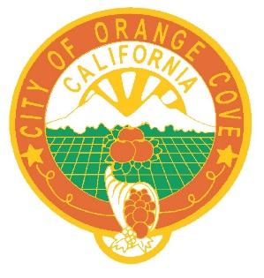

NOTICE AND CALL
Orange Cove City Council

NOTICE IS HEREBY GIVEN that the Regular City Council Meeting of July 28, 2021 has been moved to the Council Chambers located at 633 6th Street, Orange Cove. Originally it was posted that the Council Meeting will be held at the Senior Center located at 699 6th Street, due to the technical difficulties of the Air Conditioner Unit and the health and safety of our public, the Council Meeting has been moved to the Council Chambers. Thank you.

June V. Bracamontes, City Clerk
City of Orange Cove
July 28, 2021

