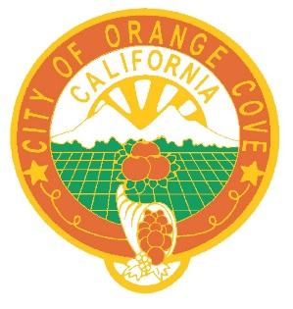

NOTICE AND CALL
Orange Cove City Council

NOTICE IS HEREBY GIVEN that the Regular City Council Meeting of November 24, 2021 and December 22, 2021 has been cancelled due to the holidays.

Thank you.

June V. Bracamontes, City Clerk
City of Orange Cove
November 22, 2021

