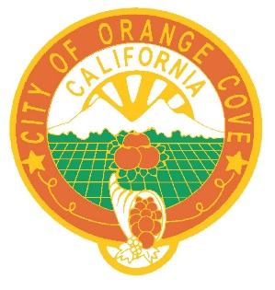

NOTICE AND CALL
Orange Cove City Council

NOTICE IS HEREBY GIVEN that the Regular City Council Meeting of December 8, 2021 has been cancelled due to the lack of a quorum and rescheduled to Tuesday, December 14, 2021 at 5:30 p.m. located in the Orange Cove Council Chambers, 633 6th Street, Orange Cove. Thank you.

June V. Bracamontes, City Clerk
City of Orange Cove
December 8, 2021

