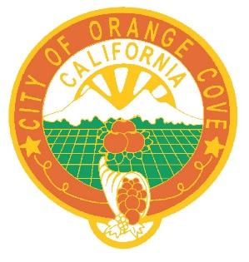

NOTICE OF CALL
Orange Cove City Council

NOTICE IS HEREBY GIVEN, that due to COVID 19 the City Council Meeting of July 13, 2022 has been cancelled and reschedule to a special meeting on July 18, 2022 at 6:30 p.m..

Thank you.

June V. Bracamontes, City Clerk
City of Orange Cove
July 13, 2022

